

**Course-Code: SE2002**

**Software Design & Architecture**

# Use Case Specifications

# Final Semester Project PAK Airline Flight Management System

**Submitted by:** Khursheed Alam Khan

**Roll#**  20i-0496

**Section:** SE-R

**Submitted to:** Dr. Zohaib Iqbal

**Submitted on:** 4th June 2022

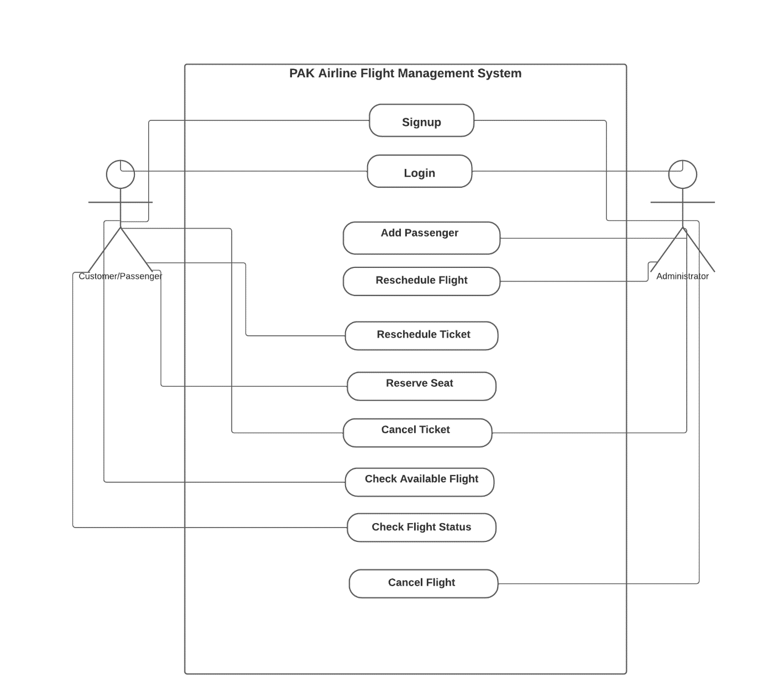

* **Use Case: Customer Reserves Seat**
* **Actors:** Customer (initiator), System
* **Purpose:** Reserve a ticket for a flight
* **Overview:** This use-case begins when the customer navigates to start reserving a ticket for a flight. When done reserving, the system updates the database with the ticket booked
* **Type:** Primary and Essential
* **Pre**-**Conditions:** Customer is a registered user and logged into the system
* **Post-Conditions:** Flight ticket is reserved and database updated

Use Case: Customer Reserves Seat

|  |  |
| --- | --- |
| Actor Action | System response |
| 1. The use case begins when the customer enters reservation of seat option |  |
| 1. The customer enters name, CNIC, phone, and gender |  |
| 1. The customer enters departure airport |  |
| 1. The customer enters arrival airport |  |
| 1. The customer enters date for departure |  |
| 1. The customer inputs Flight type: Local or International |  |
| 1. The customer chooses seat type: Economy or Business Class | 1. System displays the available flights (see 8a) |
| 1. The customer inputs slot ID to reserve a flight |  |
| 1. The customer inputs no. of seats to reserve | 1. System displays total fare information to the customer against the slot ID selected |
| 1. The customer Confirms reservation | 1. System books the ticket for the customer |
|  | 1. System updates the database with the booked ticket information |
|  | 1. System sends SMS and email to the customer |
| 1. The customer receives the SMS and email |  |

Alternative flows:

8a. If any required field is empty, inform user about empty fields.

* **Use Case: Customer Cancels Ticket**
* **Actors:** Customer (initiator), System
* **Purpose:** Cancel a booked ticket for a flight
* **Overview:** This use-case begins when the customer navigates to cancelling a ticket for an already booked flight. When done cancelling, the ticket is cancelled and the database is updated with tickets removed
* **Type:** Primary and Essential
* **Pre**-**Conditions:** Customer is a registered user, logged into the system, and has an already booked ticket
* **Post-Conditions:** Flight ticket is cancelled and database updated

Use Case: Customer Cancels ticket

|  |  |
| --- | --- |
| Actor Action | System response |
| 1. The customer selects cancel ticket option | 1. System displays cancel ticket interface |
| 1. The customer enters ticket number | 1. System verifies ticket number (see 4a) |
|  | 1. System displays ticket information to the customer |
| 1. The customer confirms cancellation | 1. System deletes reservation |
|  | 1. System refunds money (see 7a, 7b) |
|  | 1. System updates the database |
|  | 1. System sends SMS and email to the customer |
| 1. Customer receives the SMS and email |  |

Alternative flows:

4a. If invalid ticket number is entered, informs the user to reenter a valid ticket number.

7a. If user cancels ticket 7 days or more before the flight Date then 10% fine is deducted from refund.

7b. If user cancels ticket in 6 days or less before the flight Date then 40% fine is deducted from refund.

* **Use Case: Admin Reschedules Flight**
* **Actors:** Admin (initiator), System
* **Purpose:** Reschedule an active booked flight
* **Overview:** This use-case begins when the admin navigates to rescheduling flight for an already booked flight. When done rescheduling, the flight’s date is postponed, reason for postpone displayed, and the database is updated
* **Type:** Primary and Essential
* **Pre**-**Conditions:** Admin is a registered employee, logged into the system, and a booked flight exists
* **Post-Conditions:** Flight is rescheduled and database updated

Use Case: Admin Reschedules flight

|  |  |
| --- | --- |
| Actor Action | System response |
| 1. Admin selects reschedule flight | 1. System takes admin to reschedule flight interface |
| 1. Admin enters flight number | 1. System displays flight details list (see 4a) |
| 1. Admin enters reason for postponement |  |
| 1. Admin enters new date for the flight |  |
| 1. Admin confirms rescheduling | 1. System updates the flight Date along with the reason for rescheduling |
|  | 1. System sends SMS to the customers and the Admin |
| 1. Admin receives the SMS |  |

Alternative flows:

4a. If invalid flight number, informs the admin to reenter a valid flight number

7a. If empty field, informs admin that he/she cannot proceed

* **Use Case: Customer Reschedules a Ticket**
* **Actors:** Customer (initiator), System
* **Purpose:** Reschedule a booked ticket for a flight
* **Overview:** This use-case begins when the customer navigates to start rescheduling ticket for an already booked flight. When done rescheduling, the system updates the ticket and the customer receives an Email/SMS of the updated ticket.
* **Type:** Primary and Essential
* **Pre**-**Conditions:** Customer is a registered user, logged into the system, and has a flight ticket booked
* **Post-Conditions:** Flight ticket is rescheduled and updated

Use Case: Customer Reschedules Ticket

|  |  |
| --- | --- |
| **Actor Action** | **System response** |
| 1. This use-case begins when the customer starts to reschedule ticket |  |
| 1. The customer enters ticket number | 1. System verifies the ticket number (see 3a) |
|  | 1. System presents slot id, ticket id, flight id, departure airport, arrival airport, seat quantity, departure Date, and flight status |
| 1. The customer enters new Date for departure |  |
| 1. The customer updates Business or Economy class | 1. System displays updated fare (see 7a, 7b, 7c) |
| 1. The customer confirms ticket rescheduling | 1. System asks for payment |
| 1. The customer confirms reschedule | 1. System reserves seat |
|  | 1. System updates the ticket |
|  | 1. System generates updated ticket |
|  | 1. System sends SMS to the customer |
| 1. The customer receives the SMS |  |

Alternative flows:

3a. If ticket number is invalid, inform customer to re-enter valid ticket number

7a. If no seats are available in the specified class then inform the customer

7b. If customer changes class from Economy to Business, add additional 15% charge to fare

7c. If customer changes class from Business to Economy, refund 15% of the total payable amount

* **Use Case: Customer Checks Available Flight**
* **Actors:** Customer (initiator), System
* **Purpose:** Check available flights for a specified date
* **Overview:** This use-case begins when the customer navigates to start checking flight for a specified date. The system presents the available flight for the mentioned date and the customer exits the system after obtaining the information required.
* **Type:** Primary and Essential
* **Pre**-**Conditions:** Customer is a registered user and is logged into the system
* **Post-Conditions:** Information of available flights displayed

Use Case: Customer Checks available flight

|  |  |
| --- | --- |
| **Actor Action** | **System response** |
| 1. This use-case begins when the customer starts to check available flights |  |
| 1. The customer selects between Local and International flight |  |
| 1. The customer enters flight details i.e. departure airport, arrival airport, and Date | 1. System pulls information from its database and displays all the flights available in the specified Date to the customer (see 4a) |
| 1. The customer gains the desired information from the displayed details regarding the available flights |  |

Alternative flows:

4a. If no flight is available on specified Date, present the nearest flight Dates to the customer

4b. If no flight is available for the specified Local arrival airport, display “Flight Unavailable” message along with an associated reason for the unavailability

4c. If no flight is available for the specified International arrival airport, display “Flight Unavailable” message along with an associated reason for the unavailability

* **Use Case: Customer Checks Flight Status**
* **Actors:** Customer (initiator), System
* **Purpose:** Check the flight status of a booked ticket
* **Overview:** This use-case begins when the customer navigates to start checking flight status for an already booked ticket. System presents the status of the flight; the customer acknowledges and exits the system.
* **Type:** Primary and Essential
* **Pre-Conditions:** Customer is a registered user, logged into the system, and has a flight ticket booked
* **Post-Conditions:** Flight status is displayed

Use Case: Customer Checks Flight Status

|  |  |
| --- | --- |
| **Actor Action** | **System response** |
| 1. This use-case begins when the customer starts to check flight status |  |
| 1. The customer enters ticket ID to check the flight status | 1. System verifies ticket ID (see 3a) |
|  | 1. System presents the status of the flight along with additional information i.e. departure airport, arrival airport, seat class, seat number, any reason for postponement, customer name, customer CNC, and departure Date to the customer (see 4a). |
| 1. The customer gains the desired information from the displayed details regarding the flight status |  |

Alternative flows:

3a. If invalid ticket ID, system presents an “invalid ticket ID” message and informs the customer to re-enter a valid ticket ID

4a. If flight is delayed/postponed, systems presents the reason for delay/postpone and allows the customer to cancel or keep the ticket

* **Use Case: Admin Adds Passenger**
* **Actors:** Admin (initiator), System
* **Purpose:** Add a new passenger to the flight booking system
* **Overview:** This use-case begins when the admin navigates to start adding new passengers into the system. System adds the passengers and the customer becomes a registered user
* **Type:** Primary and Essential
* **Pre-Conditions:** Admin is a registered employee and logged into the system
* **Post-Conditions:** Passenger is registered to the system

Use Case: Admin Adds Passenger

|  |  |
| --- | --- |
| Actor Action | System response |
| 1. The use case begins when the customer begins adding a passenger to the system |  |
| 1. Admin enters passenger’s name |  |
| 1. Admin enters passenger’s password |  |
| 1. Admin enters passenger’s CNIC |  |
| 1. Admin enters passenger’s email |  |
| 1. Admin enters passenger’s age |  |
| 1. Admin enters passenger’s gender |  |
| 1. Admin confirms adding the passenger details | 1. System updates the customer credential database (see 9a, 9b, 9c) |
|  | 1. System to adds the passenger |
|  | 1. System sends SMS and email to the Admin |
| 1. Admin receives the SMS and email |  |

Alternative flows:

9a.If customer is already registered, his details are updated in the database with the new information entered by the admin

9b.if all fields are not filled system shows message to enter all fields

9c.if security check requirements are not fulfilled for example CNIC is not of 13 digits system, then the system shows invalid input error

* **Use Case: Admin Cancels Ticket**
* **Actors:** Administrator (initiator), System
* **Purpose:** Cancel a booked ticket for a flight
* **Overview:** This use-case begins when the admin navigates to cancelling a ticket for an already booked flight. When done cancelling, the ticket is cancelled and the database is updated with tickets removed
* **Type:** Primary and Essential
* **Pre**-**Conditions:** Admin is a registered user, logged into the system, and system contains data about booked tickets
* **Post-Conditions:** Flight ticket is cancelled and database updated

Use Case: Admin Cancels Ticket

|  |  |
| --- | --- |
| Actor Action | System response |
| 1. The use case begins when the admin enters cancelling ticket menu |  |
| 1. The admin enters the ticket number | 1. System verifies the ticket number against its database (see 3a.) |
|  | 1. System displays ticket information to the admin |
| 1. The admin confirms the cancellation of the ticket | 1. System removes the ticket |
|  | 1. System updates the database |
|  | 1. System sends SMS and email to the admin |
| 1. The admin receives the SMS and email |  |

Alternative flows:

3a.If ticket number is incorrect, show incorrect exception message

* **Use Case: Admin Cancels Flight**
* **Actors:** Administrator (initiator), System
* **Purpose:** Cancel a flight
* **Overview:** This use-case begins when the admin navigates to cancelling a flight that is already being booked by passengers. When done cancelling, the flight is cancelled and the database is updated with flight removed
* **Type:** Primary and Essential
* **Pre**-**Conditions:** Admin is a registered user, logged into the system, and system contains data about booked flights
* **Post-Conditions:** Flight ticket is cancelled and database updated

Use Case: Admin Cancels Flight

|  |  |
| --- | --- |
| Actor Action | System response |
| 1. The use case begins when the admin enters cancelling flight menu |  |
| 1. The admin enters the flight code | 1. System verifies the flight code against its database (see 3a.) |
|  | 1. System displays flight information to the admin |
| 1. The admin confirms the cancellation of the flight | 1. System removes the flight |
|  | 1. System updates the database |
|  | 1. System sends SMS and email to the admin |
| 1. The admin receives the SMS and email |  |

Alternative flows:

3a.If flight code is incorrect, system shows incorrect exception message